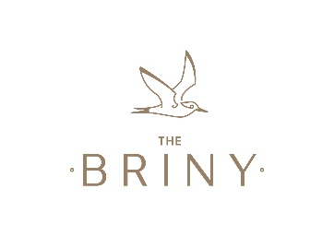
Role: Team Leader, 45 hours, 5 days inc weekends across a 7 day rota
Opening hours: 9am – 11pm
Hourly Pay: £9.20 per hour (plus tips £100+ a week)
Who are we?
The Briny is a family-run seafood restaurant, serving up excellent food and drink with a casual beachfront vibe. Panoramic sea views from every vantage point, combined with our exceptional level of customer service make The Briny a must-visit on the South Coast.
Who are we looking for?
An exceptional Team Leader to work alongside our Manager to lead a team of dynamic, fresh-faced, hardworking staff.
The successful candidate will have:
- Experience leading a team in a hospitality setting
- A friendly and confident demeanour
- Exemplary customer service
- Be ready to roll their sleeves up and get involved; a hands-on attitude – leading by example
- Exceptional eye for detail
- Excellent communication skills
Main roles and responsibilities:
- Keyholder opening up and closing down securely.
- Setting up the restaurant and managing front of house & kitchen teams.
- Provide exceptional customer service at all times and ensure staff are following your lead, building an excellent rapport with customers.
- Ensure high levels of cleanliness and hygiene are met at all times.
- Train and develop front of house staff.
- Cash handling and till reconciliation.
- Stock Management: ordering and taking delivery of food, beverages & cleaning products, liaising with the kitchen team.
We will offer:
- A competitive salary and excellent tips
- Beautiful, buzzing work environment
- Strong, friendly team
- Personal development and training
- Free food when working and 20% discount at our sister restaurants

