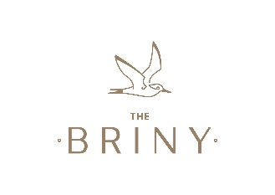
Role: Summer Chef, 45 hours, 5 days inc weekends, across a 7 day rota
Our Opening Hours: 9 am – 11pm
Hourly Pay plus tips (£100+ a week):
Age 16 – 17: £5
Age 18 – 20: £6.56
Age 21 – 22: £8.36
Age 23+: £8.91

Who are we?
The Briny is a family-run seafood restaurant, serving up excellent food and drink with a casual beachfront vibe.
Our ingredients are sourced from the best suppliers, where possible locally and our team will always be happy to share with the customer, the journey from farm or sea to plate.
Our team of chefs led by Head Chef Cameron, are passionate about showing those ingredients the respect they deserve and the customer can enjoy watching them create their very own masterpiece in our open kitchen.
Who are we looking for?

Experience in a professional kitchen is essential.

Speed, accuracy and passion.

A chef who enjoys working as part of a small team in a fast-paced environment.

Enthusiasm, energy, and a keenness to embrace new ideas.
Main Responsibilities:
- Producing menu items in accordance with the Head Chef’s instructions.
- Taking delivery of food from suppliers
- Maintaining the highest levels of cleanliness and hygiene at all times

We will offer:
- Beautiful, buzzing work environment
- Strong, friendly team
- Personal development and training
- Free food when working and 20% discount at our sister restaurants

